
Name: Abdul Samad
Program: BSSE Group A
Semester: 5th
Date: October 21, 2026
*-----------------------------------------------*

Lab Task 7
Activity Diagram for the given Scenario:

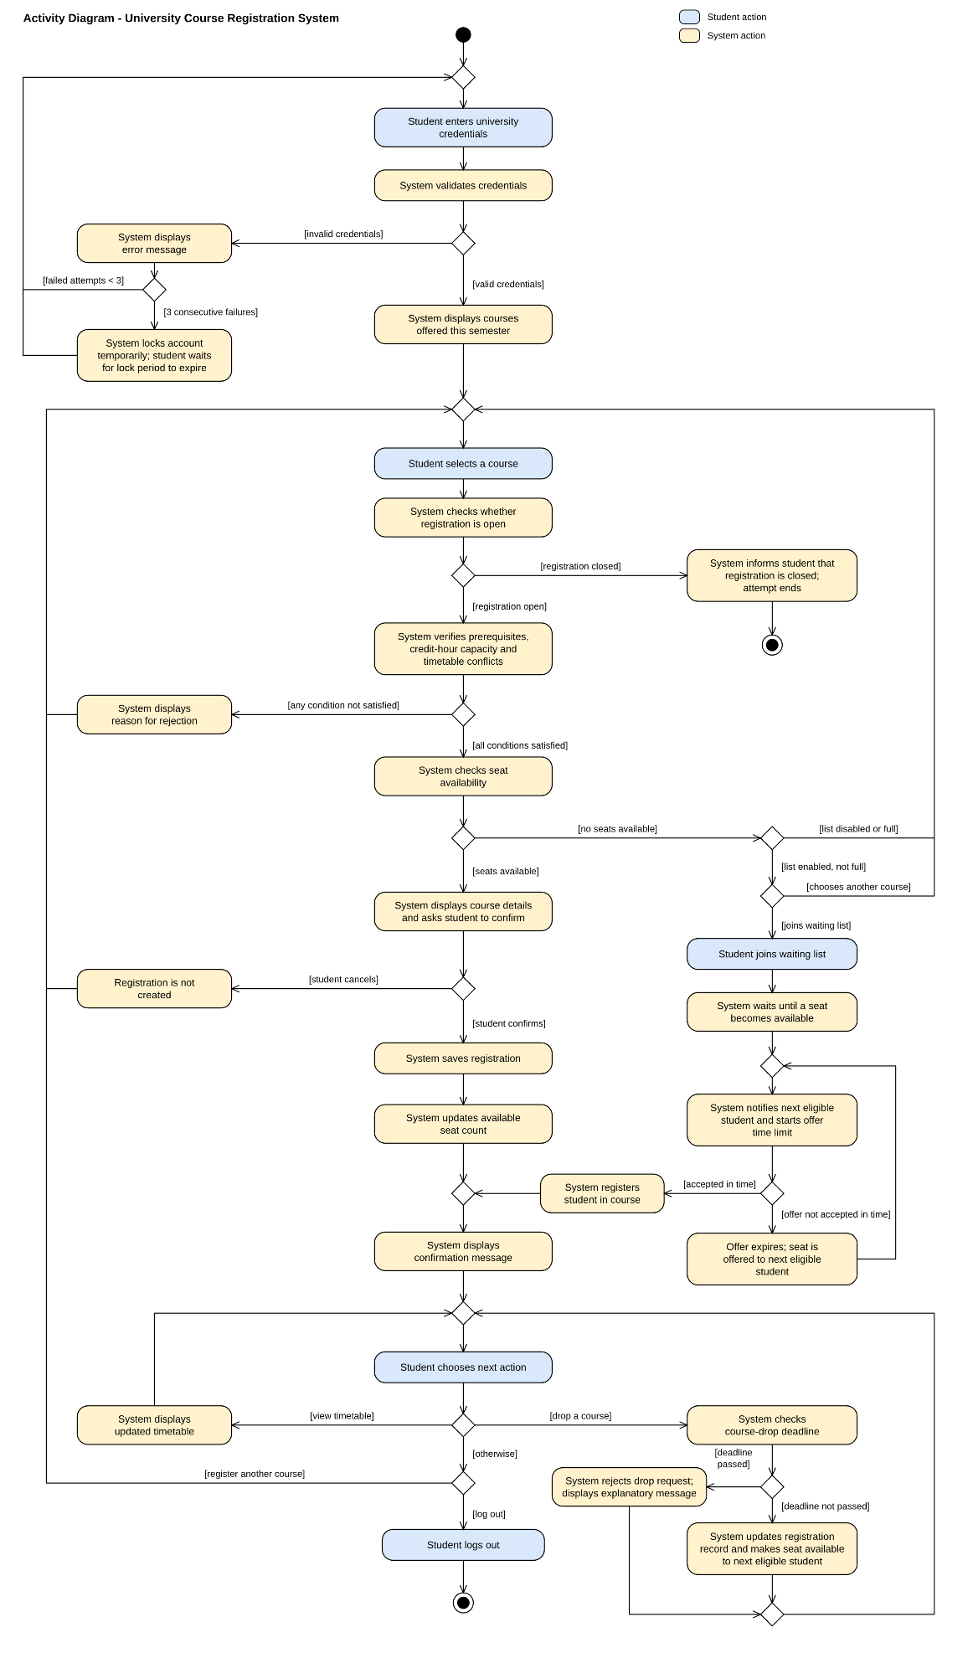

State Transition Diagram for the given Scenario:

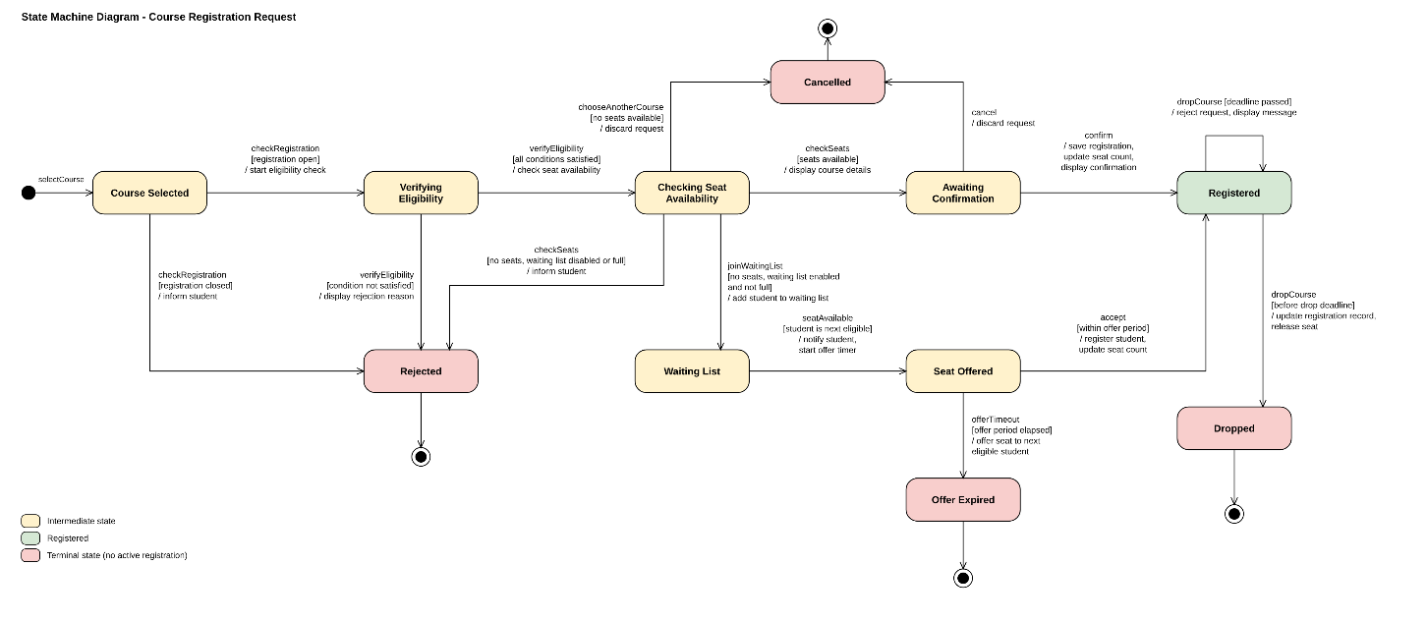
*-----------------------------------------------*

The End

